Code 11

# Configuration Doc For Installing Flutter

# Version Information :

|  |  |  |  |
| --- | --- | --- | --- |
| Version | Name | Comment | Date |
| 1.0 | Sameer | Initial Draft | 4/7/2018 |

**Configuration Document for Installing Flutter**

The installation is self-explanatory in the Flutter IO Website :

Link : <https://flutter.io/get-started/install/>

Windows Configuration :

Make sure you have atleast 10GB of space in your system.

Flutter SDK:

Download Link : <https://flutter.io/sdk-archive/#windows>

Download the ZIP file, extract it and place it in any of the folder like C:/Flutter

Install GIT :

Download from : <https://git-scm.com/>

Pretty straight forward installation

Install Android Studio :

Download from : <https://developer.android.com/studio/>

Do a default installation.

Make sure you have configured the following Environment Path :

Path : Control Panel\System and Security\System\ChangeSettings\Advanced\Environmetvariable\System Variables

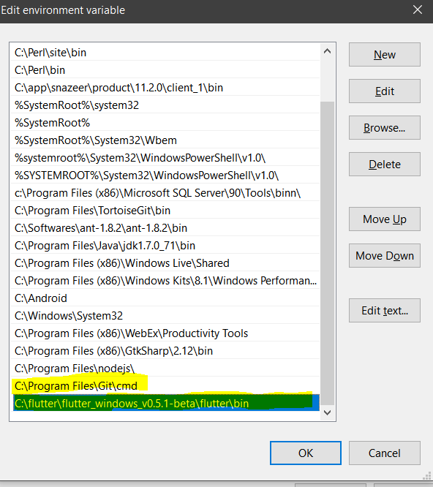

Open CMD and Run the following command : flutter doctor

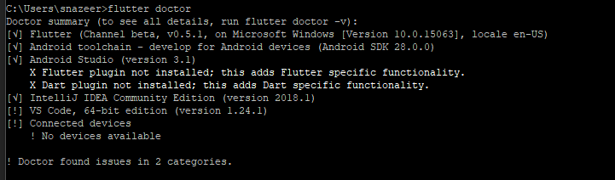

Make sure you have Tick Mark on first 4. The last two ! is not required.

If you don’t have tick in first 4, make sure to correct it.

END OF DOC